实验报告：

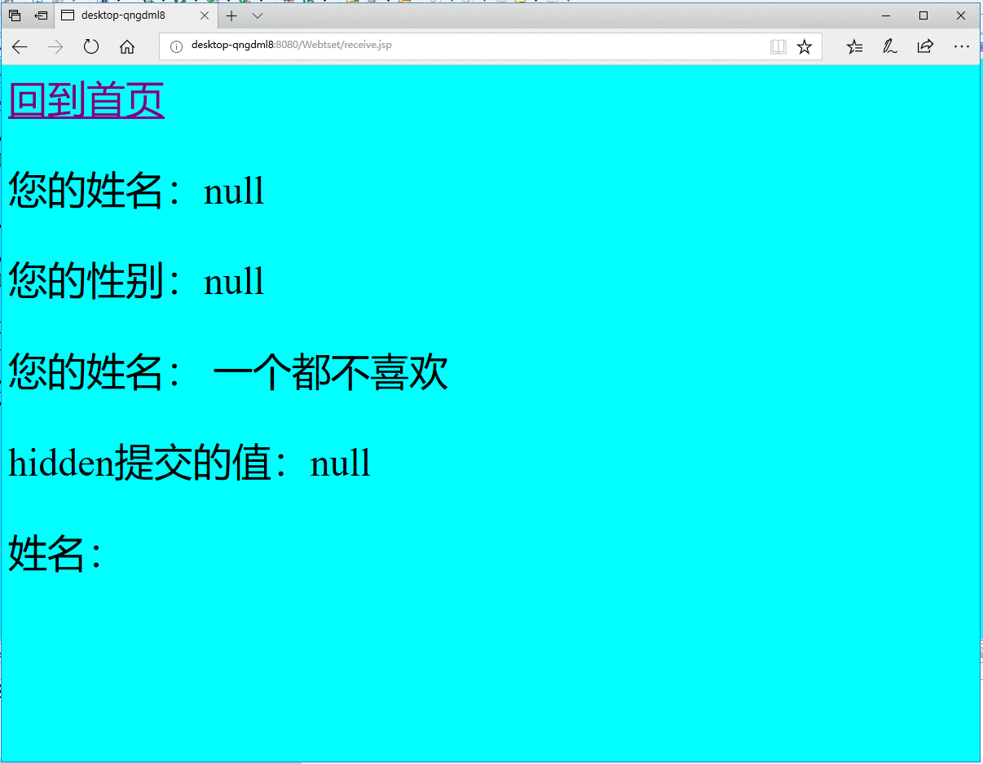

<%@ page contentType=*"text/html;charset=utf-8"*%>

<HTML><BODY bgcolor=*cyan*>

<Font size=*8*> <a href=*"index.jsp"*>回到首页</a>

<% request.setCharacterEncoding("utf-8");

String yourName=request.getParameter("name");

String yourSex=request.getParameter("R");

String secretMess=request.getParameter("secret");

String personName[]=request.getParameterValues("secretar");

out.println("<P> 您的姓名："+yourName+"</P> ");

out.println("<P> 您的性别："+yourSex+"</P> ");

out.println("<P> 您的姓名：");

**if**(personName==**null**){

out.print("一个都不喜欢");

}

**else**{

**for**(**int** k=0;k<personName.length;k++)

{

out.print(" "+personName[k]);

} }

out.print("<P> hidden提交的值："+secretMess);

%>

<P>姓名：${param.name}<FONT></BODY></HTML>

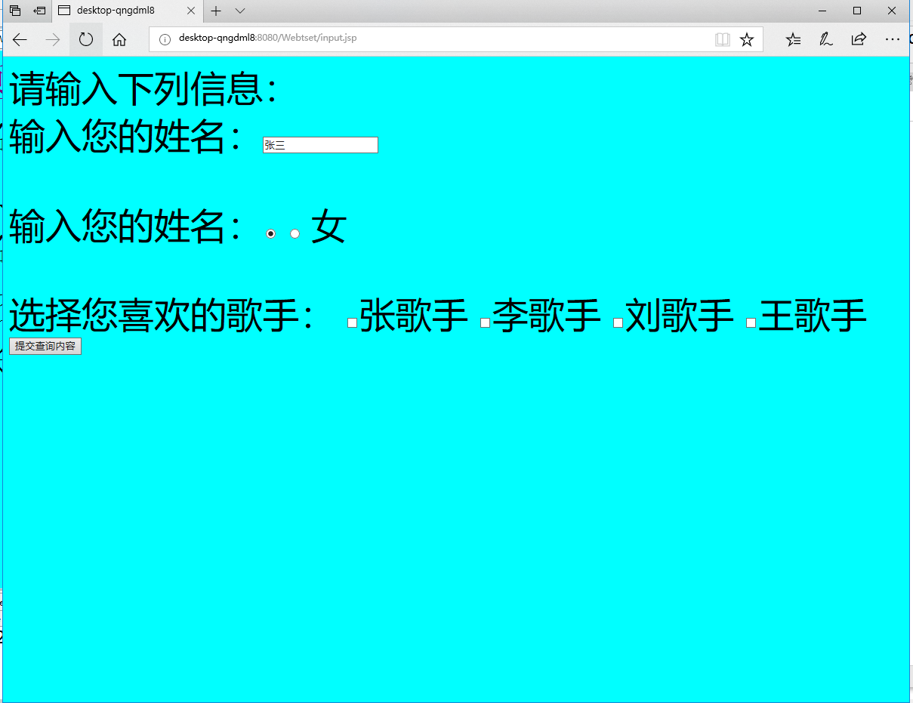<%@ page contentType=*"text/html;charset=utf-8"*%>

<HTML><BODY bgcolor=*cyan*><Font size=*8*>

<FORM action = *" receive.jsp"* method =*post* name=*form*>

<P>请输入下列信息：

<BR>输入您的姓名：<INPUT type=*"test"* name=*"name"* value=*"张三"*> </BR>

<BR>输入您的姓名：<INPUT type=*"radio"* name=*"R"* value=*"男"* checked=*"d "*>

<INPUT type=*"radio"* name=*"R"* value=*"女"*> 女

</BR>

<BR>选择您喜欢的歌手：

<input type=*"checkbox"* name = *"superstar"* value "张歌手">张歌手

<input type=*"checkbox"* name = *"superstar"* value "李歌手">李歌手

<input type=*"checkbox"* name = *"superstar"* value "刘歌手">刘歌手

<input type=*"checkbox"* name = *"superstar"* value "王歌手">王歌手

</BR>

<INPUT TYPE=*"hidden"* name=*"这是隐藏信息"* name=*"secret"*>

<INPUT TYPE=*"submit"* name=*"提交"* name=*"submit"*>

</FORM>

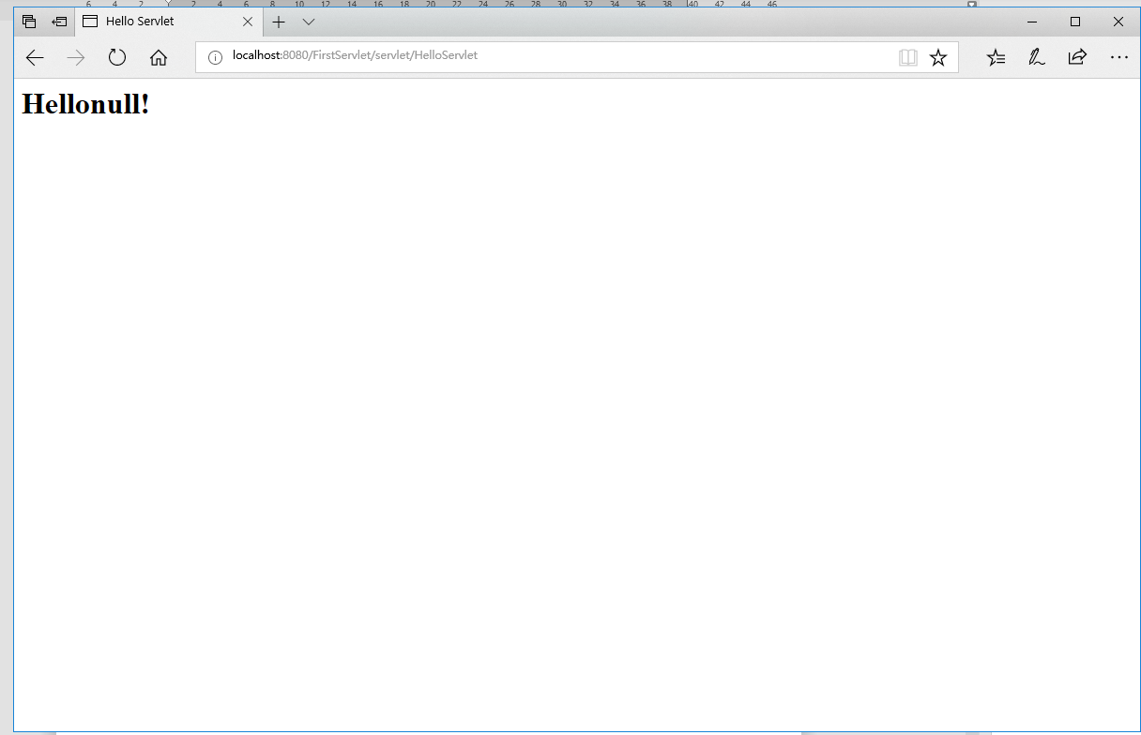**package** cc.openhome;

**import** java.io.IOException;

**import** java.io.PrintWriter;

**import** javax.servlet.ServletException;

**import** javax.servlet.http.HttpServlet;

**import** javax.servlet.http.HttpServletRequest;

**import** javax.servlet.http.HttpServletResponse;

**public** **class** HelloServlet **extends** HttpServlet {

**public** **void** doGet(HttpServletRequest request, HttpServletResponse response)

**throws** ServletException, IOException {

response.setContentType("text/html;charest=UTF-8");

PrintWriter out = response.getWriter();

String name =request.getParameter("name;");

out.println("<html>");

out.println("<head>");

out.println(" <title>Hello Servlet</title>");

out.println(" </head>");

out.print(" <body> ");

//out.print(this.getClass());

out.println("<h1> Hello"+ name +"!</h1>");

out.println(" </body>");

out.println("</html>");

//out.flush();

out.close();

}

}